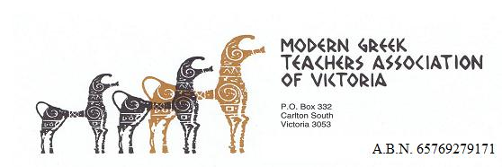

Registration Form
VCE (Modern Greek) Student Seminar
7th August 2016, ERC - Charles Pearson Theatre, University of Melbourne,
10.30 a.m. – 12.30 p.m.
Register in 2 easy steps
1. Complete the following and return to the MGTAV (mgta.vic@gmail.com) before Friday 29th July 2016
School / Provider Name:
Teacher in Charge:
Teacher contact number (mobile):
Number of students:
Number of teachers:
Please return the above to the MGTAV before Friday 29th July 2016 please. email: mgta.vic@gmail.com
2. Then make your payment by EFT or send a cheque to the MGTAV before Friday 29th July, 2016 please.
Details regarding payment are on the next page.

PAYMENT
EFT payment:
NAB Account: Modern Greek Teachers’ Association of Victoria
BSB: 083 – 019
Account: 51- 518 - 5403
Reference: << YOUR NAME OR SCHOOL >>

Put in your name or school’s name so that we may send you your receipt.

OR

Post your cheque made out to the MGTAV to:
MGTAV
PO Box 332
Carlton South 3053

Please email us your completed VCE Student Seminar registration form/information before Friday 29 July – mgta.vic@gmail.com

Please call us on 0411 789 798 if you need any further help!

