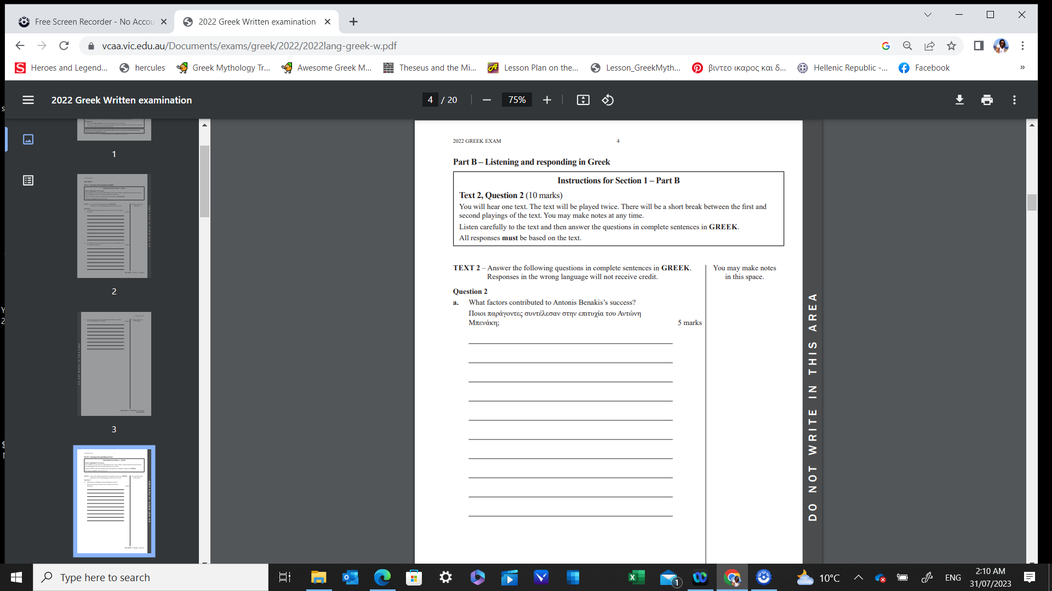

**MGTAV VCE Greek Written Exam Section 1 2023 – Practice Question**